## **Deployment document for bug fixes #54, #51, #52 and #53**

1. ***Fix for issue #54 (Document Manager –Pulling wrong CVision log):***
   1. Set the value of CVISION_TRAPEZE_LICENSE_USAGE_LOG key in Document Processor/config.js file to 'C:/ProgramData/CVision/Trapeze/logs/licerr.log',



* 1. Start document processor
  2. Test the url in Postman,

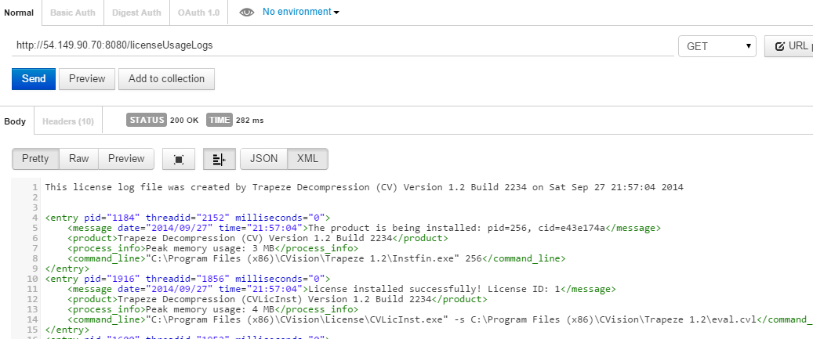

* 1. Alternatively, you can also replace the file submission/files/documentProcessor/config.js to Document processor/config.js.

1. ***Fix for #51 (Document Processing Instance unavailable), #52 (Error downloading log file), #53 (Need to keep file name same)***
   1. Copy the file submission/files/DocumentService.js to Document Manager/services/DocumentService.js.
   2. Copy the file submission/files/documentManager/config.js to Document Manager/config.js. (NOTE: The only change in the file is that the value of DOCUMENT_PROCESSOR_MAX_IDLE_TIME is and should be greater than PROCESS_DOCUMENTS_JOB_INTERVAL)
   3. Running document manager and upload some files to the box input folder
   4. Verify from the log files in document manager/logs that, there are no errors and file is processed successfully.
   5. The output file should have same name as input file,

